About elearning for healthcare (elfh)
elearning for healthcare (elfh) is is an NHS England programme in partnership with the NHS, social care and professional bodies which provides elearning programmes to educate and train the health and care workforce.

The learning programmes are developed in partnership with the NHS, third sector and professional bodies and are available free of charge to those working in health and care.

How to access elfh content
There are several ways to access elfh learning content:
- Self-Registration
Individuals create an account for themselves
- Bulk Upload
Organisations can use this service to arrange accounts for employees
- Via own Learning Management System (LMS)
Access to content is provided via AICC links. SCORM files are not available.
- OpenAthens
Anyone with an existing NHS OpenAthens account can use these details to sign into elfh

elfh User Accounts
Both the self-registration and bulk upload methods create a learning account which is personal to an individual. All staff need an individual email address (work or personal) to access the learning.

Ideally a work email address in the individual’s name should be used (if available) so that the registration results in the most appropriate access to e-learning content. Email addresses such as manager@carehome.co.uk may be refused due to GDPR principles.
NOTE: If a personal email address is used, the available e-learning content should be sufficient for those working in social care, volunteers and for individuals registering for personal use.

Users can produce personal learning activity reports from their accounts as well as obtaining certificates for many of the courses available.

As the accounts are personal to an individual and not the organisation, they can take their learning with them if they change roles or employer. This is simply done by editing the email address and place of work on their individual account.

Ways to Register

Self-Registration
Individuals can register here https://portal.e-lfh.org.uk/Register

Anyone with an email domain on our allowed list (including but not limited to @nhs, @gov, @ac.uk) will proceed straight to the Registration Details page:
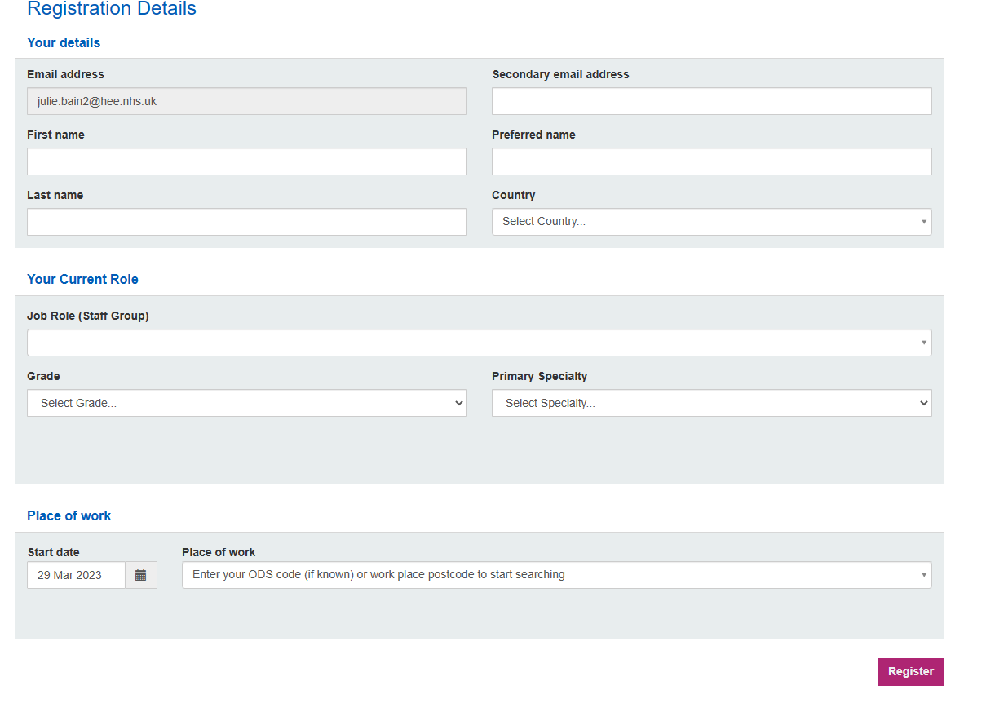
The fields should be filled out as appropriate, for Job Role (Staff Group) if an exact match for isn’t available then the closest match should be chosen, or the option of ‘Other (unknown)’.

The drop-down options for Grade and Primary Specialty will become available (if applicable) once a job role is chosen.

For Place of work if no correct address is listed then ‘Unknown location (unknown)’ should be used.

Selecting these options will not limit the learning available.

Once the registration process is complete an email will be sent to the individual with their log in details. The email will come from no.reply@e-lfh.org.uk and may go into the spam folder. The link to set a confidential password will last for two weeks after which it can be reset from https://portal.e-lfh.org.uk/forgotten-password

Anyone with an email domain not our allowed list) will proceed to the Registration page and should choose the most appropriate option:
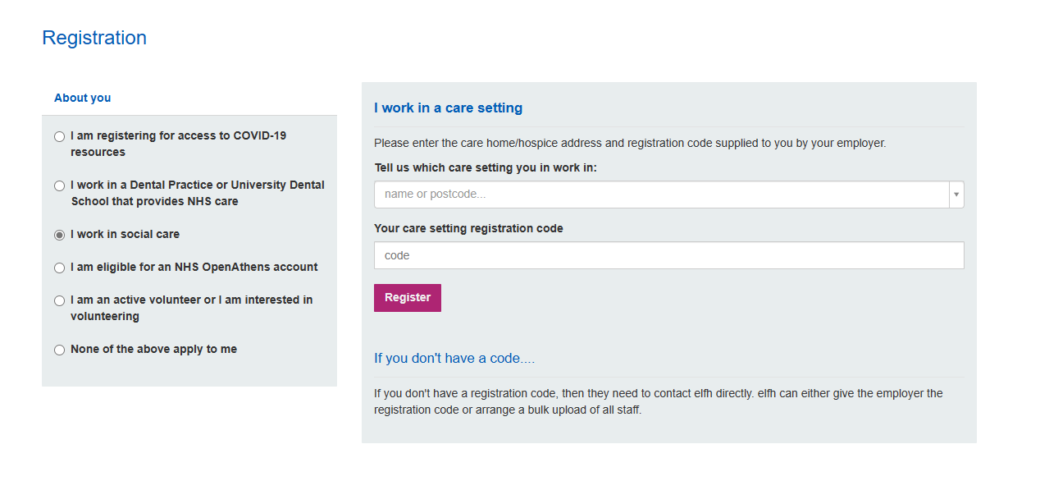
Those working in social care need a registration code to register. This code can be obtained by contacting elfh support.

If the option of ‘None of the above apply to me’ is chosen the following screen is displayed:
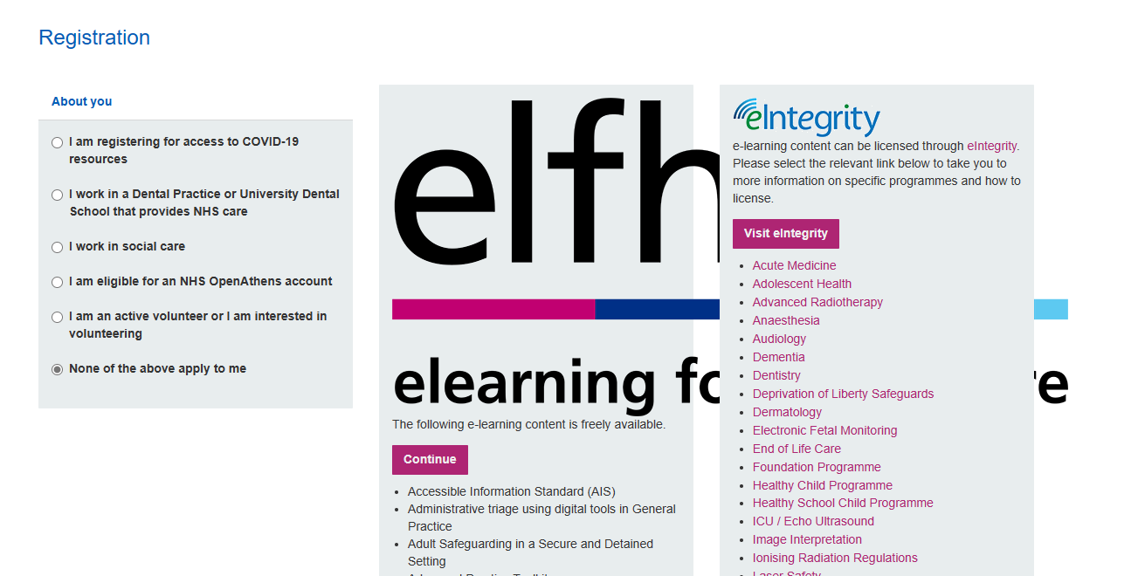

Selecting ‘Continue’ will allow access to a reduced number of courses.

NOTE: Organisations asking employees to self-register should ensure they contact elfh support first to obtain the correct registration code. If the correct code is not user this can lead to limited access to content or employees not appearing on reporting if it has been set up. Further information on reporting is available in a separate document.

Bulk Upload
The bulk upload process is a quick, easy way for an organisation to ensure that all staff are enrolled on the correct learning in one go. There is no limit on the number of accounts we can create, although the larger the request the longer it will take us to process.

A spreadsheet is completed by an organisation and returned to elfh support with the details of the employees needing to be registered. The accounts are then created for you and log in details sent out to staff via email.

A personal learning account is created for each individual and this can be retained by them if they move to a new place of work. An individual email address is needed for us to create the account (named work email addresses are preferable but personal ones are acceptable if these aren’t available).

Everyone is sent an email with their username and a link to set their password and managers are provided with confirmation of all the usernames for their employees via a password protected spreadsheet.

Employers can track progress via a suite of reports. Further information on reporting is available in a separate document.

Additional local admin functionality is available to organisations which allows nominated individuals additional permissions on their account so they can manage their employees – giving the ability to add new employees, update personal details (e.g., email address), send password resets and add additional courses to your users. It also has the functionality to remove employees from your reporting location when they leave your organisation.

A Memorandum of Understanding (MoU) needs to be completed to add this additional functionality.

Via own Learning Management System (LMS)
It may be possible to link to elfh resources from your Learning Management System (LMS), by using AICC links. AICC allows data to be transferred from one place to another, meaning we can share our content with organisations running their own LMS without needing to send the session files.

AICC will enable your LMS to record the launching, duration, score and status of sessions held on the elfh content server. However, as certificates are only produced by our LMS and not the sessions themselves, if you run our content on your own LMS via our AICC links, you will need to create your own certificate for them.

Our AICC links always remain the same, which means that if content is updated on the elfh Hub, the changes will be reflected in any LMS using an AICC link to that content.

We can support organisations in configuring a standard Moodle LMS to launch remote AICC enabled sessions. Whilst we expect other iterations of Moodle derived platforms to be similar, we cannot test or advise on every Moodle instance, unfortunately.

If you have a standard Moodle LMS and wish to explore the possibility of AICC links, please visit our AICC report page at HEE elfh Hub (e-lfh.org.uk) to ensure the content is available and contact our support team to complete the process at Home - elfh Support (e-lfh.org.uk) via live chat or raising a support ticket.

It is important to contact us if you intend to use our AICC links, so that we can help you to set these up in your LMS and issue a Memorandum of Understanding (MoU).

OpenAthens
Anyone with an existing NHS OpenAthens account can use these details to sign into elfh by selecting the option 'Sign On with OpenAthens'.

More information on how to do this can be found on our support site:
http://support.e-lfh.org.uk/get-started/logging-in-and-out/how-do-i-use-my-openathens-account-to-access-the-hee-elfh-hub/

* Terms of reference

ODS Code
This is a unique identification code from the Organisation Data Service (ODS) for organisations that interact with any area of the NHS.

Organisations such as hospitals / GP practices / social care providers often have an ODS code. Please contact elfh to check if there is such a code available for your organisation.

Requests for new codes can be made via
https://digital.nhs.uk/services/organisation-data-service/new-code-requests

Further Information
Our website https://www.e-lfh.org.uk/

Our support site https://support.e-lfh.org.uk/home/

Email: support@e-lfh.org.uk

