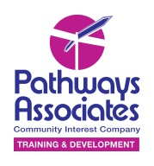
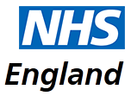 | We are helping NHS England and Baywater Healthcare write some accessible information about sleep machines (CPAP).
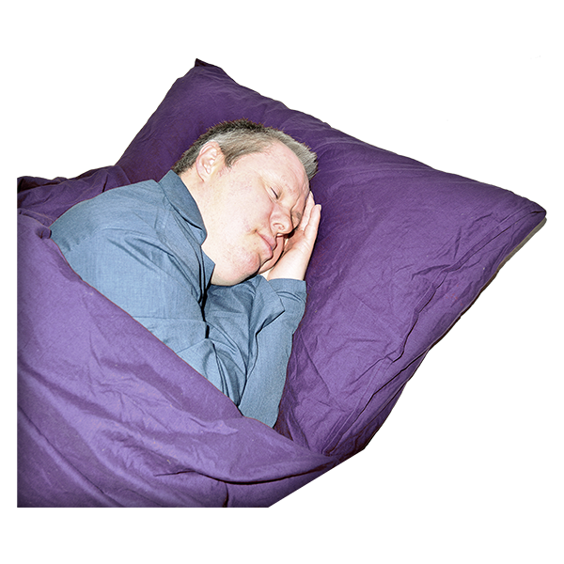 | Sleep machines (CPAP) are used to treat something called Obstructive Sleep Apnoea. This is when your breathing stops and starts while you sleep. Your breathing stops because your airway closes.
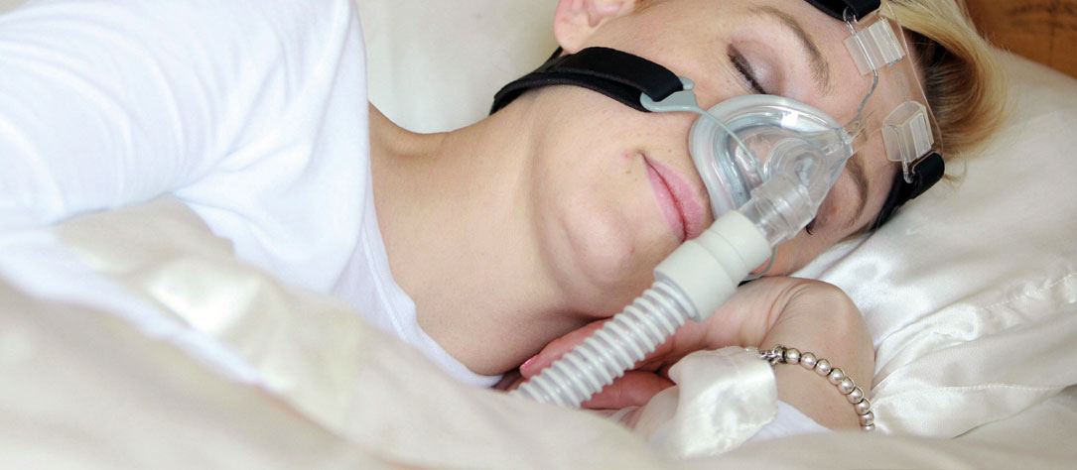 | Sleep machines (CPAP) work by blowing air through a mask into your nose or mouth. The air stops your airway from closing and returns your breathing to normal while you sleep. This will make you feel less sleepy in the daytime.
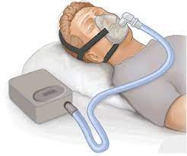 | A sleep machine (CPAP) may feel strange at first with the strong air blowing into the mask. Some people get used to them after the first few nights, but others may take longer.
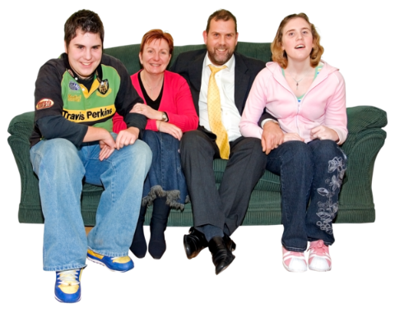 | We want to talk to people with a learning disability, or autistic people who have a sleep machine (CPAP). Even those who cannot or do not use it.
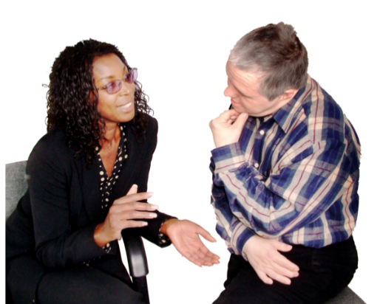 | We want to talk to family members and support staff who help someone with a learning disability or autism who use a sleep machine (CPAP).
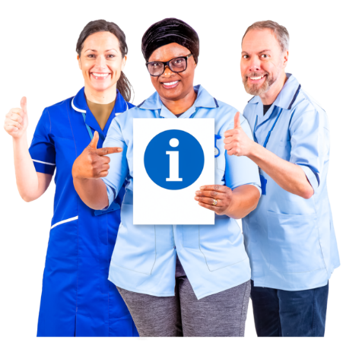 | We want to understand all the issues people have with using a sleep machine (CPAP) and find out what information would be useful. This will help us to create some useful materials (such as leaflets, videos, guidelines) that people can find helpful.
 | Want to find out more & help?  Click on this link to be involved:  https://forms.gle/UpqfHNZ1d3mGWiFZA  You can register your contact details and we can arrange to meet online in a group.
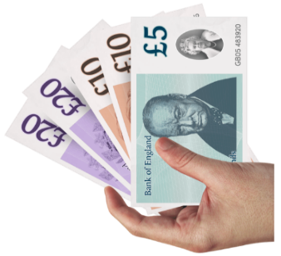 | We will pay you for your involvement in focus groups.  Please also complete this survey.  https://www.surveymonkey.co.uk/r/SleepMachines

