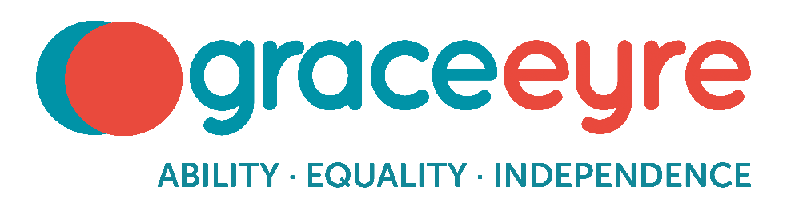
Trustee Recruitment Pack

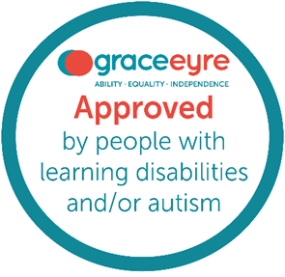

Contents

  - About the Grace Eyre Foundation – page 3
  - What do we do? – page 5, 6
  - What is our plan? – page 7, 8, 9
  - Our Board of Trustees and Governance Structure – page 10
  - Our Executive Team – page 10
  - Role of a Trustee at the Grace Eyre Foundation – page 11, 12
  - How Meetings Work – page 13, 14
  - Expectations of individual Trustee’s – page 15, 16
  - What Support do Trustees have? – page 17
  - How to apply? – page 18
  - Jargon Buster – page 19, 20

1. About the Grace Eyre Foundation
 | The Grace Eyre Foundation is one of the oldest charities in Brighton & Hove. We were founded by social care pioneer Grace Eyre Woodhead in 1898. We provide social care to adults with a learning disability and/or autism across Sussex.
 | Grace Eyre’s vision is for a society where people with learning disabilities and autism can fulfil their dreams and wishes, are respected as equal citizens, and are part of, and contribute to their communities.
 | Grace Eyre’s mission is to deliver Our Charter created by people with learning disabilities and/or autism.

Our Charter – The people we support say:

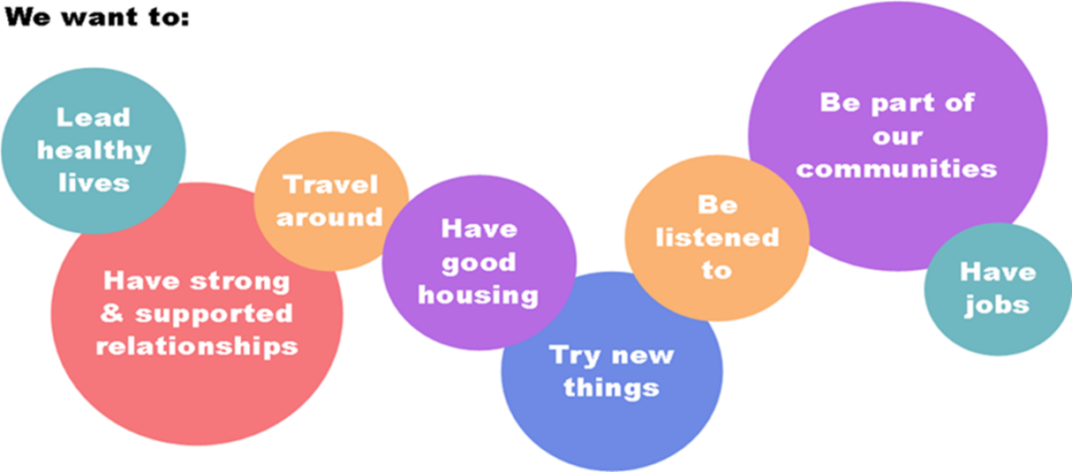

Our Values
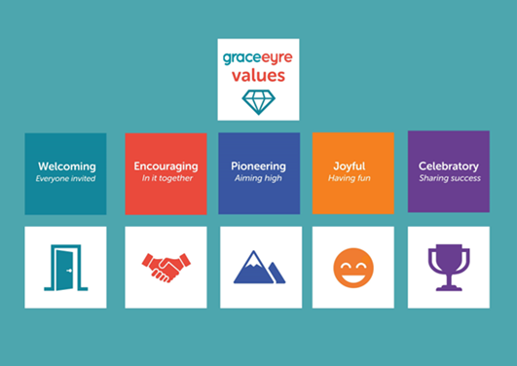

2. What do we do?
 | Choices is our supported living service, which provides unique support for each person’s need, so they can really enjoy living independently.  Choices also provides outreach service in Brighton & Hove and across West Sussex as well as The Reach, our drop-in Centre.
 | Shared Lives matches people who are 16 years old or older who need support from a Shared Lives carer who offers care and support, as well as a room in their own home.
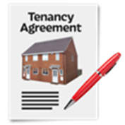 | Grace Eyre Housing supports tenants to live a more independent life in their own homes, as part of their local community.  Grace Eyre Housing leases properties in Brighton and Hove and West Sussex and works in partnership with landlords, letting and management agencies, local authorities, and support providers.
 | Active Lives  We are all about people, fun, friendship and having new experiences in a safe and supported environment.  The variety of activities on offer will engage you, nurture your ambitions and enrich your life.
 | Employment continues to be a Grace Eyre focus. Currently we are delivering numeracy skills for employment through our Multiply project. We will have more announcements for new projects coming soon.  Grace Eyre is working closely with employers, increasing their disability awareness and understanding.
 | Our Voices is a department that supports people with Learning Disabilities and autistic people to have their voices heard and be included in the design, monitoring and delivery of Grace Eyre services.
 | Campaigning  We know that by educating and changing opinions, we can change behaviours.  The 5 campaigns we will focus on are:  - Client Contribution Cost Campaign  - Disability Discrimination  - Healthcare  - Employment  - Benefits

3. What is our plan?
 | Currently, Our Plan is from 2020 to 2027.
 | Our plan lays out a strategy to deliver excellent services for and led by people with learning disabilities and/or autism, as well as introducing our Big Build project.
 | We made good progress, but we are creating a new strategy for 2026 to 2029.
 | FINANCE & SERVICES OBJECTIVES
 | We will be financially sustainable.
 | We will achieve full cost recovery for Shared Lives by 2027 and maintain full cost recovery for Choices, Housing and Active Lives.
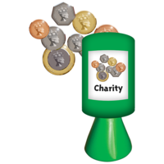 | We will achieve fundraised income to support our key projects and for the Big Build.
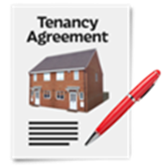 | We will achieve trading income to ensure we can deliver good housing and 2 trading projects.
 | We will ensure people with a learning disability and autistic people are employed in our communities.
 | QUALITY & IMPROVEMENT; GOVERNANCE
 | We will continue to develop the Quality Management Framework for Choices, Active Lives, Shared Lives and Housing by using Quality Checkers.
 | We are improving our use of technology to support staff and the people we support.
 | We will monitor, evaluate, and report on our impact so that we can measure the difference we make.
 | We will improve board performance by supporting trustees with lived experience, and ensuring reporting is easy read. We will measure Trustee involvement by 'volunteer hours'.
 | EQUALITY, DIVERSITY & INCLUSION; WORKFORCE
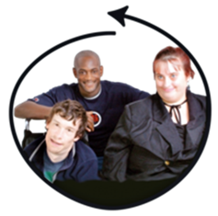 | Through our Inclusion Strategy, we will be stronger by listening to people with learning disabilities and autistic people and reflecting on the Sussex communities we engage with.
 | We will remain an Employer of Choice by our staff.
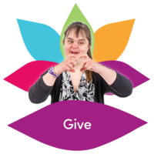 | We will develop a Volunteer Strategy that will recruit and support volunteers.
 | PARTNERSHIPS & SUSTAINABILITY
 | We will harness the power of partnerships to achieve more.
 | We are reducing our environmental footprint.
4. Our Board of Trustees and Governance Structure
5. Our Executive Team
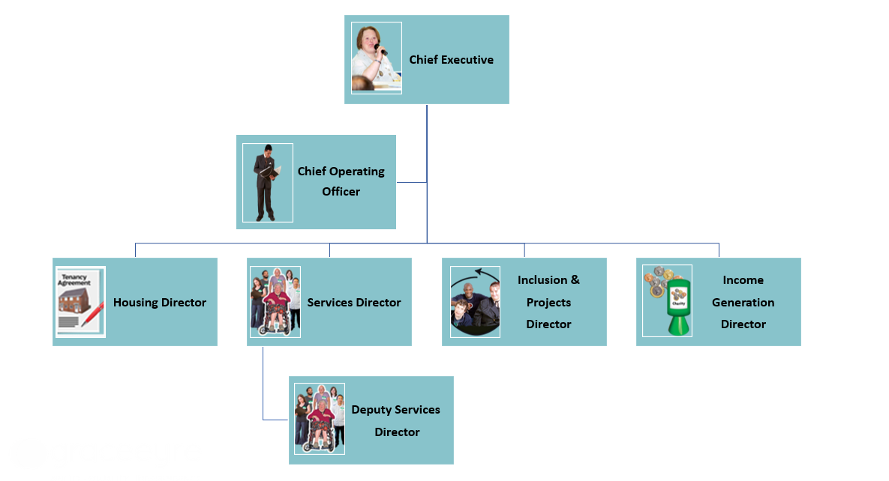

6. Role of a Trustee at the Grace Eyre Foundation
 | You will be registered as a Trustee of Grace Eyre at the Charity Commission for England and Wales.
 | You will be registered as a Director of Grace Eyre at Companies House.
 | You will ensure Grace Eyre does what it says it will.
 | You will be responsible for the charity.
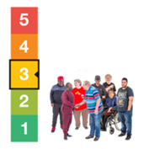 | You will choose what is most important for the charity.
 | You will make plans for the future of Grace Eyre.
 | You will make sure the charity follows the rules of the  charity.
 | You will make sure there are rules called articles of association and policies, about how the charity will get things done.
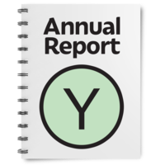 | You will be responsible to tell people how Grace Eyre is spending its money. These are called ‘Accounts’.

7. How meetings work
 | You will have 5 x Board of Trustees meetings every year.
 | The Board of Trustees Meetings are 2 hours, from 06:30pm to 08:30pm.
 | Most meetings are in person, but some might be online.
 | The executive directors provide a briefing before each meeting, and a debriefing after each meeting to assist you.
 | The Executive Team present the reports to the Board of Trustees.
 | You will have 1 x Board of Trustees Away Day for strategic planning.
 | The Board of Trustees Away Day is 6 hours, from 10:00am to 04:00pm.
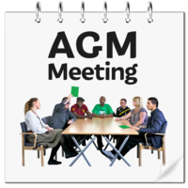 | We have 1 x Annual General Meeting once a year in October or November. All members are invited.
 | The Annual General Meeting is 2 hours, from 06:30pm to 08:30pm.
 | You can choose to become a member of the Audit and Risk Committee.
 | The Audit and Risk Committee has 4 meetings in person per year.
 | The Audit and Risk Committee Meetings are 2 hours, from 06:30pm to 08:30pm.

8. Expectations of individual Trustees
 | To attend meetings regularly, and to let us know if you can't make it.
 | To talk openly and clearly in meetings.
 | To take time to read papers and briefings before meetings.
 | To be committed to helping the charity achieve its goals for people with learning disabilities and/or autism.
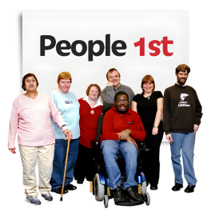 | To be ready and willing to do what's best for the charity.
 | To join in the strategic leadership as a Board Trustee, in line with the charity's goals and values.
 | To share your experience, knowledge, and skills to help Grace Eyre's services grow and excel.
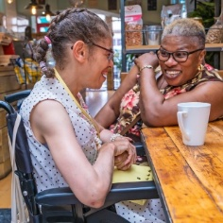 | To represent Grace Eyre in the community.
 | To respect the confidentiality of Grace Eyre and the people we support.

9. What Support do Trustees have?
 | We welcome Trustees with lived experience; we provide pre-briefs and debriefs for:  - Board Meetings  - Committee Meetings  - Trustee Away Days  These offer an opportunity to prepare for and reflect on the topics of the meeting. As well as to feedback on how accessible these meetings were and what can be done differently next time.
 | We have Jargon Buster Cards.  When Trustees raise these cards, it informs the person talking that they need to use more accessible language.  This supports meaningful inclusion and full participation for all Trustees.
 | We are starting a new buddy system, where every Trustee pairs up with a fellow Trustee.  The Trustees will have a designated person to offer insight, support, and to answer any queries.  The buddy system also offers an informal way to learn about new skills and perspectives which an individual Trustee may not have had the opportunity to explore before.

- How to apply?
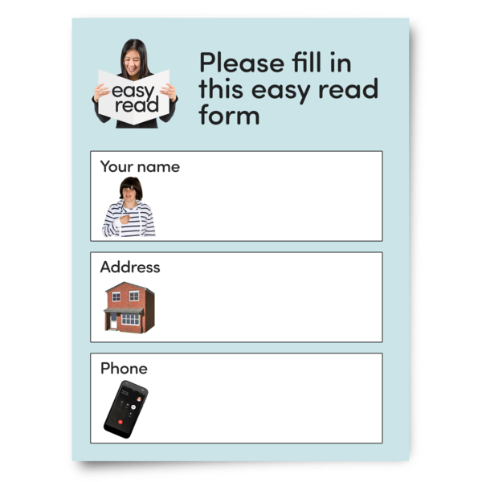 | Fill out the application form.  If you need assistance, please contact Zoe Ablitt zablitt@grace-eyre.org (Governance Manager).  The application form is shared with you along with this paper.
 | Applications will be shortlisted; we may contact you to arrange an interview.
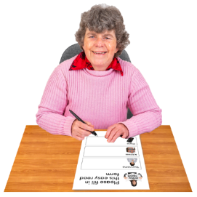 | If your application is successful, we will ask you to fill out some forms and arrange your induction.

11. Jargon Buster Section?
Audit and Risk Committee

Looks at how Grace Eyre is managing with their money, and managing the risks the charity is/could be facing.
Big Build Committee

Prepares Grace Eyre for, and advises Grace Eyre on, the continuing building project called the Big Build.

The Big Build is a project where Grace Eyre is having major building works on our previous headquarters in Montefiore Road. By the end of the Big Build, we will have;
- Office Space
- Accessible Theatre and bar
- New Flats and tenants
- New activity spaces
Charity Commission

Charity Commission makes sure that Charities in England and Wales are following the rules. These rules focus on the governance of the charity, including the responsibilities and details of the Trustees of Grace Eyre.
 | Director of Grace Eyre  As Trustees you are counted by Company House as directors of the company. This is a different role to the executive directors who report to the Trustees.
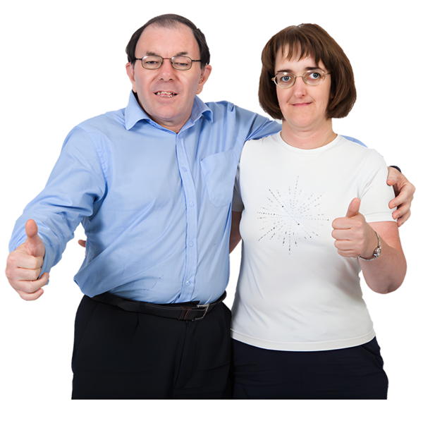 | Reference/s  This refers to person/s who can tell the organisation about your experience and skills within other organisations you went to/supported/worked at previously.
 | Treasurer  A person(s) who takes responsibility for the organisation’s money.
 | Board of Trustee’s  A group of people who are legally responsible for a Charity. They work to make sure the Charity runs the way it is supposed to.

