Job title | Non-Executive Sub Committee Member
Directorate | Board | Service | Board
Reporting to | Chair – NCHA Care Committee | People manager | No
Scale & job family | Board – Level 4 | Work style | Partially agile
DBS requirements | None | Role profile reviewed | 01/08/2022

About the role
Purpose
To ensure compliance with legal and regulatory obligations by directing and supervising NCHA’s care and support services. This will align with the requirements of the Care Act 2014 and regulations for supporting vulnerable people.

Key Activities of the Care Committee
Assess our care and support services for quality assurance and regulatory compliance according to the Care Act 2014. They also keep abreast of developments or changes to legislation and regulatory guidance.
Review and scrutinise policies, procedures and training programmes according to quality management and regulatory compliance.
Review systems and practices designed to maintain external, independently accredited and internal quality standards.
Monitor and evaluate safeguarding processes and procedures within the organisation. They will assess all operational risks around care and support. This includes the quality or care provided, safeguarding and overseeing the complaints process.

Key Tasks for Care Committee Members
Be a role model and promote our values and organisational culture, in line with our mission and objectives.
Review key documents, including policies and performance and safeguarding reports. You’ll use these to identity trends and make recommendations to the Board for improvements.
Monitor compliance with legislative and regulatory guidance overseen by the Care Quality Commission and other organisations. Where needed you’ll make appropriate recommendations for improvements.
Review and scrutinise systems, practices and performance data to maintain external accreditation and internal quality standards. This will help to ensure the necessary outcomes are being delivered in line with current regulations.
Review and sign off policies and procedures.
Monitor and evaluate safeguarding processes and procedures across NCHA.
Analyse information around safeguarding and trends, Duty of Candour and complaints. We’ll use this to recommend areas where close monitoring may be required.
Align our quality assurance, safeguarding and compliance objectives, to ensure consistency throughout the Board and Audit Sub-Committee.
Uphold our Code of Governance and Code of Conduct.

About the person (criteria used to shortlist applications)
Knowledge | Demonstrates knowledge of the issues facing the housing with care sector as a working professional or due to personal experience.  Understands how a board/sub-committee operates.
Skills and experience | Ability to understand reports and verbal briefings.  Ability and willingness to communicate views clearly and objectively.  Experience of receiving a care and support service from NCHA or being a carer or family member of someone who receives a care and support service from NCHA.
Personal qualities, values and behaviours | A willingness to devote the necessary time and effort to meet Care Committee requirements.  Strong commitment and empathy with the values, aims and objectives of NCHA.  Ability to work effectively as a member of a team.  Understands the needs of diverse communities, including people with disabilities and social disadvantages, when developing and delivering services.  Demonstrates sound independent judgement.
Other role related requirements | Regularly attend meetings. These are a minimum of 4 meetings per year. Currently 2 of these are face to face meetings in Nottingham and 2 are on MS teams. There is also an electronic pack of meeting papers and reports which is distributed one week before each meeting. You will need to have the time to familiarise yourself with the content of these before each meeting.  Keep up to date with information and knowledge relating to care and support by attending any relevant training or conferences.  A willingness to accept the legal duties, responsibilities and liabilities of trusteeship. This includes meeting the fit and proper persons test under the Health and Social Care Act 2008 (Regulated Activities) Regulations 2014.  Able to represent NCHA when requested.
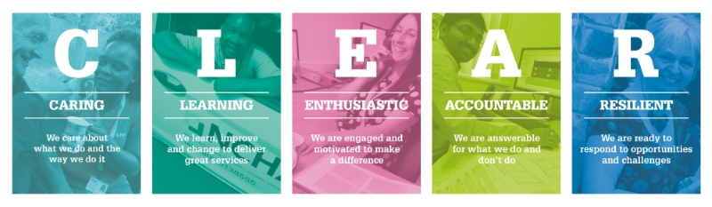
All post holders are expected to understand and comply with NCHA’s policies and procedures on Finance, Technology Services, Data Protection, Health & Safety, Equality and Diversity and any departmental policies in relation to the duties of the post. This is not a complete list of duties and responsibilities for the role, it does not form part of contractual terms and conditions. You may be required to carry out other duties commensurate with the grade of the role.

