

Trustee Application Form

 | This is for the volunteer role of a Trustee.
 | To apply, you need to fill in this form.
 | If you need help or have questions about filling in the form, you can contact:  - Zoe Ablitt  - Zablitt@grace-eyre.org  - 07934296361
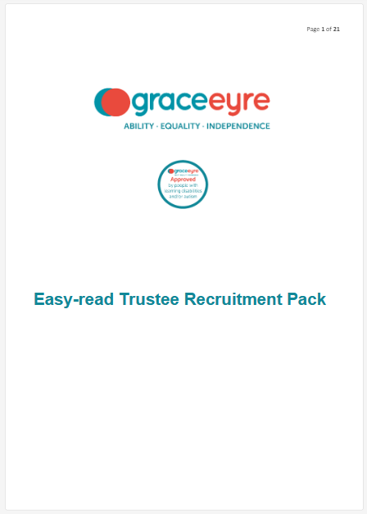 | Before you apply for this role, please read the Trustee Application Pack.  This will tell you about the role of a Trustee at The Grace Eyre Foundation.

About You
 | Full Name:
 | Address:
 | Telephone number:
 | Email address:
 | National Insurance number:
 | Are you allowed to work in the UK?
 | Yes: ☐
 | No: ☐
Criminal Record Check
 | Have you ever been in trouble with the police?
Yes: ☐
No: ☐
 | If we offer you the role, you will need a DBS check:
- This is a way to see if someone has a criminal record.
- It helps to keep people we support safe.
- It shows you are the right person to be a Trustee at The Grace Eyre Foundation.

Jobs you have had before
 | Can you tell us about any jobs you’ve had before?
 | Write your answer in the box below
What did you do? | Where did you do it? | When?

Learning you have done before
 | Can you tell us about any education or training you’ve had before?
 | Write your answer in the box below
What did you do? | Where did you do it? | When?

Why do you want to be a Trustee for Grace Eyre?
 | You could tell us about:
- Your skills and strengths that would help you to do this role well
- Anything else you think is important to tell us
 | Option 1:
 | Please contact us if you would prefer to send a video where you explain your answer.
 | - The video should not be longer than 5 minutes.
 | Option 2:
 | Write your answer in the blank box below

Returning your application form
 | When you have filled in this application form, please email it to:
 | zablitt@grace-eyre.org
 | If you have printed this form out to fill it in, please email us a scanned copy or photograph of the form.
 | Please send this form to us on or before:
 | Monday 16th February 2026.

